1. **Introduction**

A lot has been accomplished through the means of a mobile phone. We do online transactions, mobile payments through various methods, but most of our daily tasks like purchasing groceries etc. are based on cash or through bank transfers. To overcome these situations we use mobile payments through NFC-Near Field Communication. NFC is a simple and secure way for contactless data transactions between electronic devices with a simple tap or a wave. In NFC the data exchange is based on the detection of nearby devices and makes an electronic data interchange from one device to another [3]. With NFC we don’t need to enter any data manually to connect to a device or to build a link which increases the ease of using it. And with NFC the phones overall power draw is minimal as both the devices draws power from opposite one [2]. Not only for the mobile payments we can replace physical tokens with virtual tokens which can be tracked automatically there by reducing the misplacement of physical tokens.

* 1. **Overview**

In this paper we discuss the functioning and architecture of NFC mobile payments in section2, the comparison of various NFC mobile payment application interfaces like Google wallet, Apple pay, Pay pal, Square wallet in section 3 and we exploded the payment security in section 4.

1. **Implementation**

Mobile payments are of two types, Remote mobile payments and Proximity mobile payments. NFC comes under Proximity mobile payments.

**2.1. Functioning**

In proximity mobile payments we install NFC chip into a mobile phone. We enter our personal credentials like debit or credit account details into application. The application software safely secures the details and generates physical wallet often referred to as m-wallet which hold electronic cash [3].

**2.2. Architecture**

Consider the users of the application as customer and merchant. Formerly user enters his credentials into the application interface later merchant enters his ID which was given by financial service institutions.

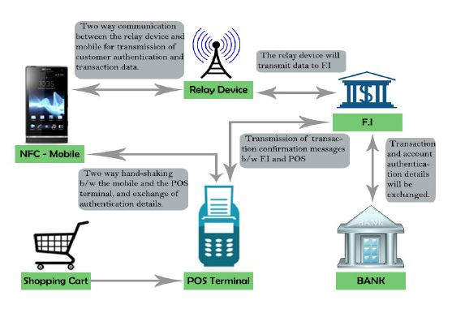

**Figure.1. NFC Architecture [1] .**

Then the financial service institutions verify the credentials of both the users. Once the verification is done, customer checks the price details and pays the bill by accepting the confirmation. Then FI verify the account of the customer to confirm that the balance in the account is sufficient for the payment or not. After validation the payment is done and a confirmation is sent to both the users [1].

**2.3. Payment Process**

Figure 2 gives us a brief description of the above mentioned concept and the payment process.

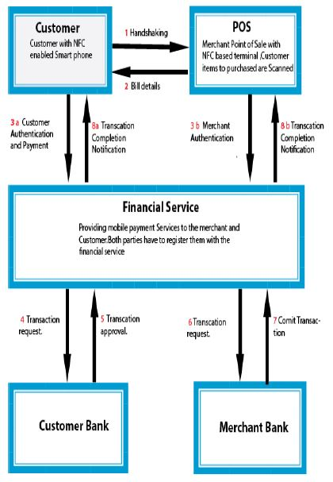

**Figure.2. Payment Process [1] .**

1. **NFC Technologies**

In this section we expose the comparison between various NFC technologies and their advantages.

**3.1. Square Wallet**

Square wallet is the most widely used NFC application which needs the information of the merchant, which only works on a specific list of merchants. It is accessible for both iOS and Android users.

**3.2. Google Wallet**

Similar to all other applications, it only works on mobiles and credit cards from the US and only in US. To add a card to Google Wallet, we can either sign into the Google Wallet site, utilize the Settings menu in the portable application or log in through our bank's site.

**3.3. Apple Pay**

Apple pay is the most secure mobile payment application. Apple Pay joins NFC innovation and the iPhone's Touch ID unique finger impression reader to accelerate checkout. Basically hold your iPhone close to the contact less reader with your finger on the Touch ID, and the mobile will vibrate and beep when checkout is finished.

**3.4. PayPal**

A "bump" strategy to exchange money or make payments between users. Paypal is another acclaimed NFC versatile installment benefit that can send money between other PayPal users and companions. Accessible for both iOS and Android, you can easily send money to different clients simply like you do on the PayPal site. It allows us to view our past transactions in point of interest.

1. **Security**

NFC has implicit security features. It is good with most existing contactless payment frameworks since they all work at the same radio frequency. In case of lost devices, some applications of NFC allow impression reader so that only authorized person can do transactions thereby avoiding the loss of personal information [2]. Through NFC applications we can generate electronic cash which is also known as mobile wallet that can be used for various mobile payments there by securing our debit or credit account details. There are several security issues like accessing the data during the transaction or interception of the transaction which are avoided by using biometric encryption [3]. Through NFC data is securely stored and administered and secure execution of the application occurs.

1. **Conclusion**

This paper exploded the usage and efficiency of NFC mobile payments. It discussed the functioning of the payment transaction between the user and the merchant. It also exploded the implementation architecture of NFC technology. This paper explained the working of various NFC application interfaces also like Google wallet, Apple pay etc. It discussed the security of NFC technology, like the usage of impression reader and implementation of biometric encryption.

**References**

[1] Shafiq ur Rehman and Jane Coughlan, An Efficient Mobile Payment System Based On NFC Technology, *proceedings of the* World Academy of Science, Engineering and Technology, vol:7, West London, United Kingdom, (June 2013), pages 1700-1704.

[2]Kasavana, M. Ph.D., Near Field Communication: Innovative Payment Technology, *proceedings of the* Michigan State University, USA (March 2013), 1-5.

[3] Ben Dodson, Hristo Bojinov, Monica S. Lam, Touch and Run with Near Field Communication (NFC), *proceedings of the* Computer Science Department Stanford University, USA (May 2010), 1-3.